**Name:-Abhya Ulhas Kumawat Roll No:- 178 Batch:- B6 Div:- B**

**Title:-5 Perform a Title on node js installation .**

**Step:1**

Open **Google crome** and search **node js download** and open the above website.

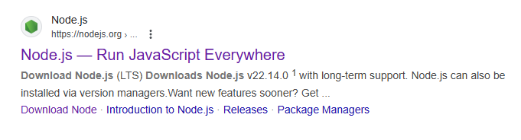

**Step:2**

Click **Download Node.js(LTS).**

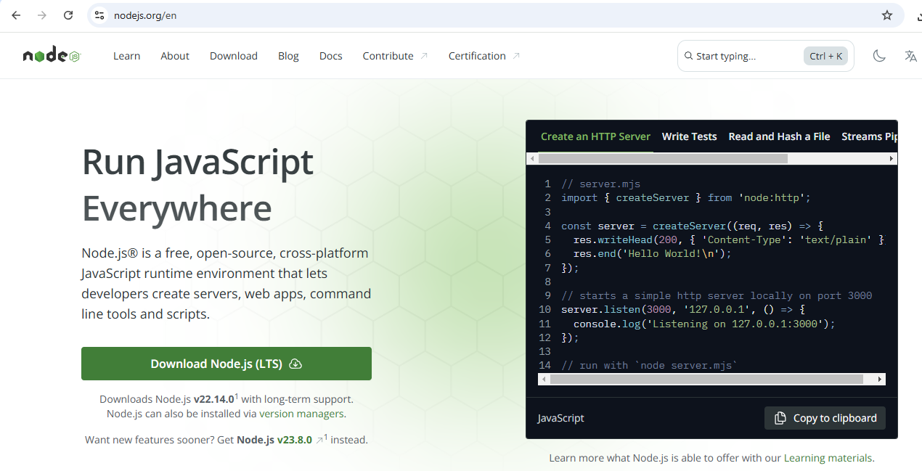

**Step:3**

Your **Download** will begin.

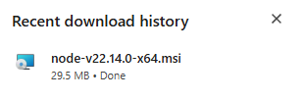

**Step:4**

Then go to **this pc** and double click on **node js** and install it.

**Step:5**

Then open to the command prompt and type command node –v and npm –v

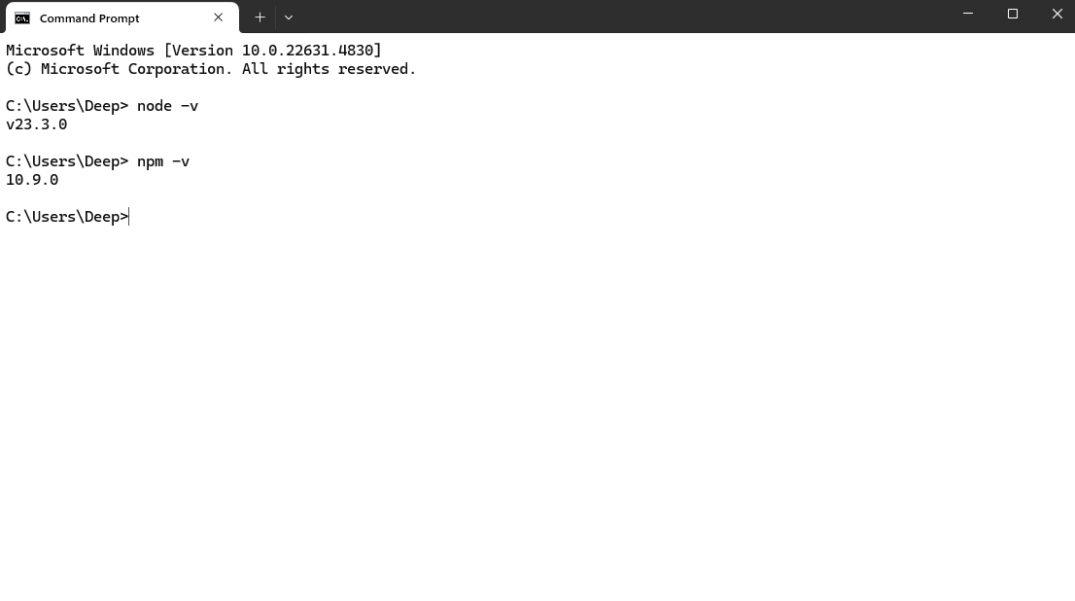

**Name:-Abhya Ulhas Kumawat Roll No:- 178 Batch:- B6**

**Div:- B**

**Title:- 7 Create a REST API with Node.js • Develop a basic REST API using Node.js that performs CR (Create, Read) operations on a simple data set.**

Step 1: Install Node.js and Initialize Your Project

Step 2: Create the API (server.js)

**Server.js:-**

// Import express to create the server

const express = require('express');

// Create an express application

const app = express();

// Define a port number

const port = 3000;

// Use middleware to parse JSON data from requests

app.use(express.json());

// Sample data for demonstration

let users = [

{ id: 1, name: 'Deep', age: 18 },

{ id: 2, name: 'Rohan', age:19 }

];

// 1. Create (POST) operation to add a new user

app.post('/users', (req, res) => {

const { name, age } = req.body; // Extract name and age from request body

// Generate a new user ID

const newUser = {

id: users.length + 1,

name,

age

};

// Add the new user to the "users" data

users.push(newUser);

// Respond with the newly created user data

res.status(201).json(newUser);

});

// 2. Read (GET) operation to get all users

app.get('/users', (req, res) => {

// Respond with all users in the data

res.json(users);

});

// Start the server

app.listen(port, () => {

console.log(`Server is running on http://localhost:${port}`);

});

Step 3: Run the Server

Step 4: Test the API

**Create a New User (POST):**

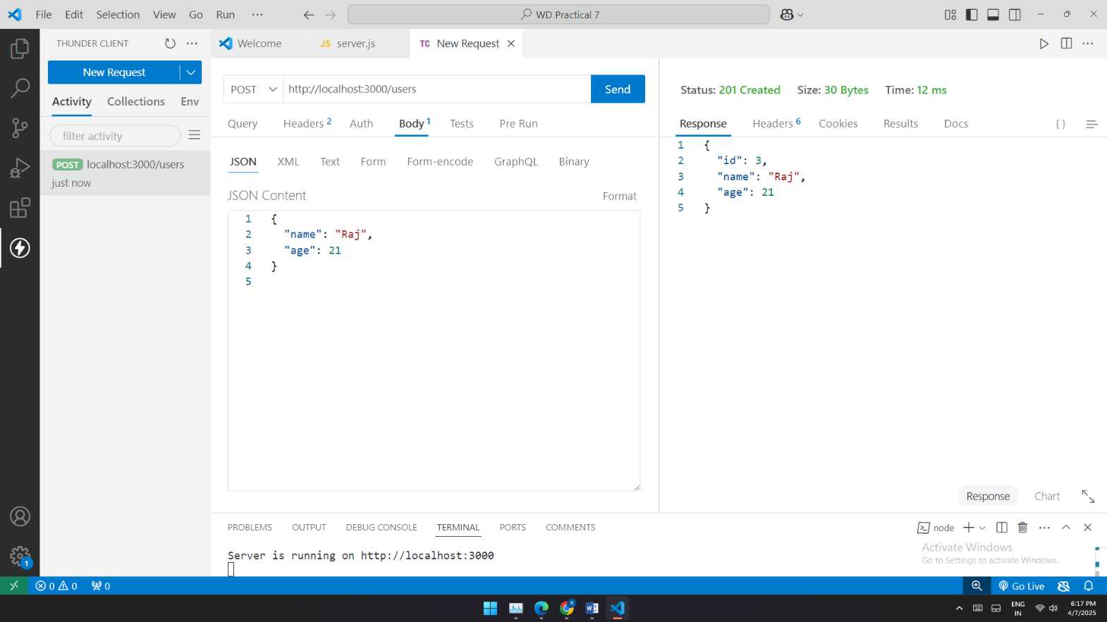

**Get All Users (GET):**

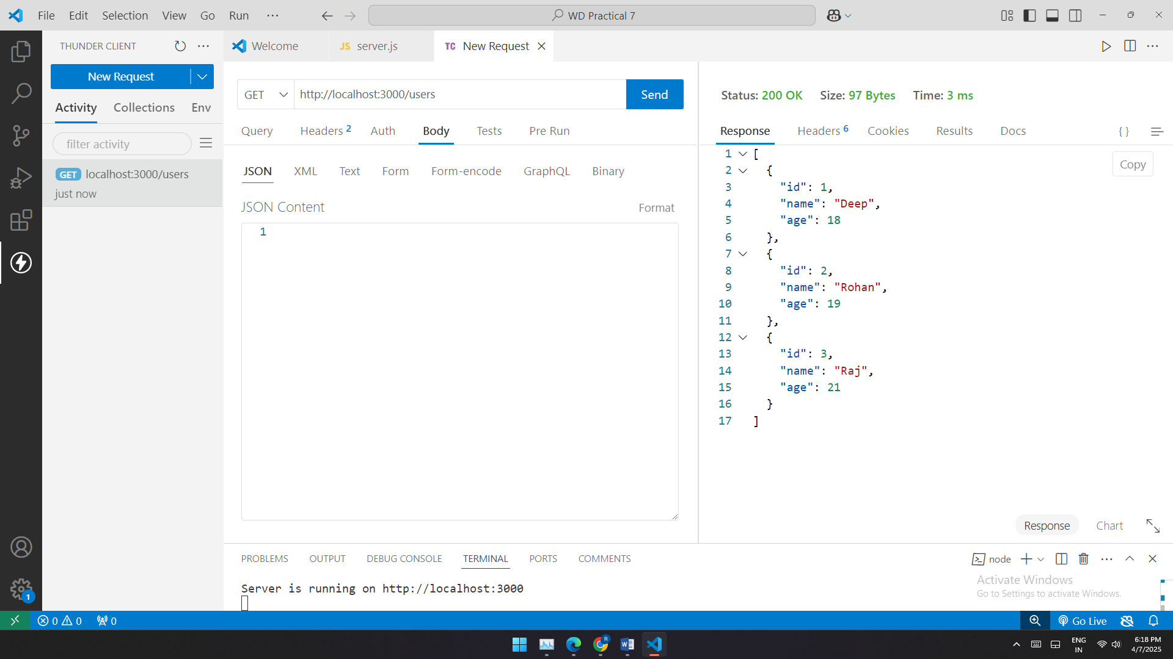

**Name:-Abhya Ulhas Kumawat Roll No:- 178 Batch:- B6**

**Div:- B**

**Prcatical no 4:Event Handling:Develop a web page where javascript respond to event(e.g,button clicks).**

<!DOCTYPE html>

<html lang="en">

<head>

    <meta charset="UTF-8">

    <meta name="viewport" content="width=device-width, initial-scale=1.0">

    <title>addEventListener Example</title>

    <style>

        body{

            font-family: cursive;

            padding: 30px;

        }

        .button-container{

            margin-top: 30px;

        }

        #message{

            margin-top: 30px;

            font-size: 1.6rem;

            font-weight: bold;

        }

        .hightlight{

            background-color: rgb(21, 69, 99);

        }

        </style>

</head>

<body>

    <h1>JavaScript Event Handling</h1>

    <button id="myButton">Touch me!</button>

<button id="ChangetextButton">Change Text </button>

<p id="message">This is original text </p>

<button id="hightlighttextbutton">Highlight Text</button>

    <script>

       //pop up

        document.getElementById("myButton").addEventListener("click", function() {

            alert("SUCCESSFUL !");

        });

//text change

document.getElementById("ChangetextButton").addEventListener("click",function()

        {

            document.getElementById("message").innerHTML="You Have Change The Text"

        });

    //mouseover

    document.getElementById("ChangetextButton").addEventListener("mouseover",function()

{

    document.getElementById("ChangetextButton").style.background="cyan";

});

//mouseout

document.getElementById("ChangetextButton").addEventListener("mouseout",function()

{

    document.getElementById("ChangetextButton").style.background="red";

});

//hightlight

document.getElementById("hightlighttextbutton").addEventListener("click",function()

        {

            const messageElement= document.getElementById("message");

            messageElement.classList.toggle("hightlight"); // Toggle highlight class

        });

    </script>

</body>

</html>

**output:**

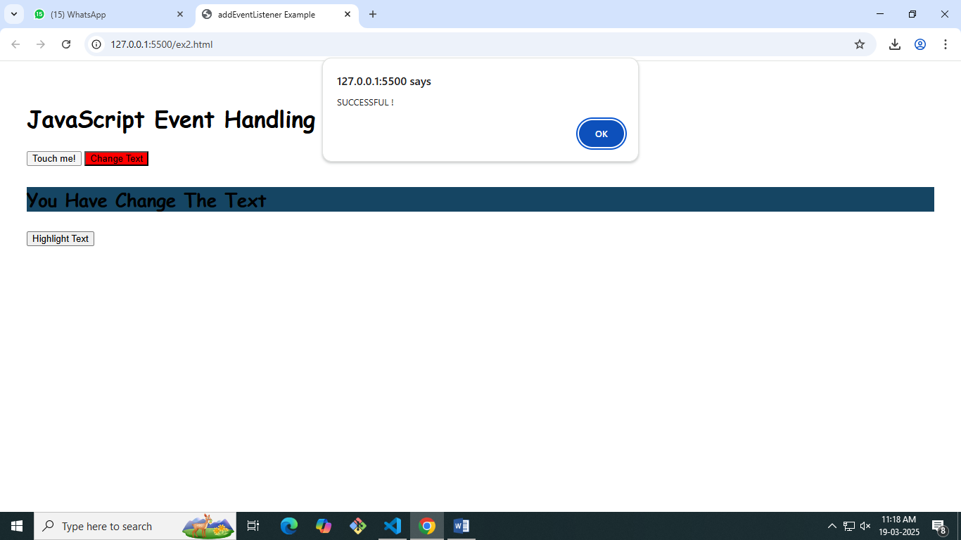

**Name:-Abhya Ulhas Kumawat Roll No:- 178 Batch:- B6**

**Div:- B**

**PRACTICAL: 6 Create a basic HTTP server using node.js that respond with “hello world! To my request**

**Server.js file**

const http = require("http");

const server = http.createServer((req,res)=> {

res.writeHead(200,{"content-type":"text/plain"});

res.end("hello everyone wellcome to my web page!");

});

const PORT = 3001;

server.listen(PORT, () =>{

    console.log(`server is running at http://localhost:${PORT}`);

});

**OUTPUT:**

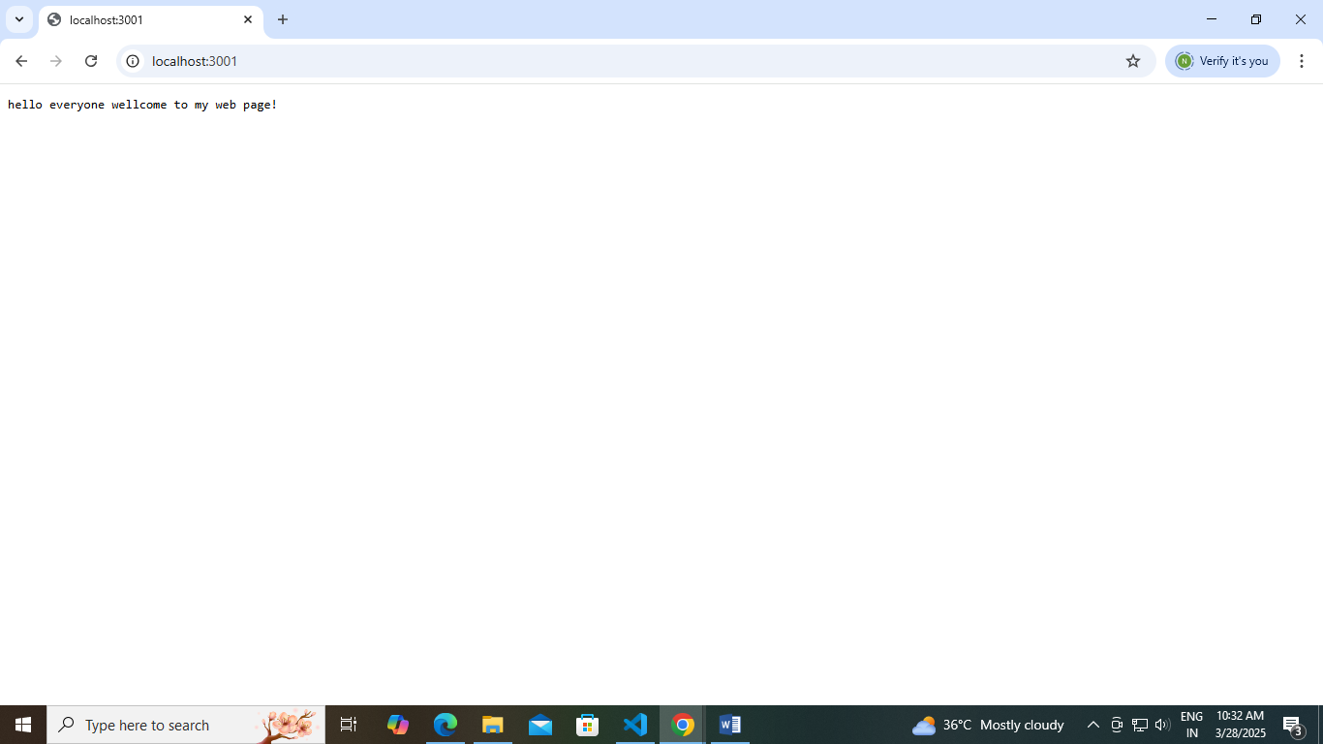

**Name:-Abhya Ulhas Kumawat Roll No:- 178 Batch:- B6**

**Div:- B**

**Practical No:-9.Perform a practical on Bootstrap setup**

<!DOCTYPE html>

<html lang="en">

<head>

    <meta charset="UTF-8">

    <meta name="viewport" content="width=device-width, initial-scale=1.0">

    <title>Latest Technology Trends</title>

    <!-- Bootstrap CSS via CDN -->

    <link href="https://cdn.jsdelivr.net/npm/bootstrap@5.3.0-alpha1/dist/css/bootstrap.min.css" rel="stylesheet">

    <style>

        .card {

            min-width: 300px;

            margin-right: 20px;

        }

        .card img {

            height: 150px;

            object-fit: cover;

        }

    </style>

</head>

<body>

    <div class="container">

        <h1 class="text-center my-4">Top 3 Latest Technologies</h1>

        <!-- Flex row for horizontal cards -->

        <div class="d-flex flex-row overflow-auto">

            <div class="card">

                <img src="D:\Pavan Kshatriya.JS\ai 2.jpg" class="card-img-top" alt="Artificial Intelligence">

                <div class="card-body">

                    <h5 class="card-title">Artificial Intelligence (AI)</h5>

                    <p class="card-text">AI enables machines to mimic human intelligence. It powers smart assistants, automation, and data-driven decisions.</p>

                </div>

            </div>

            <div class="card">

                <img src="D:\Pavan Kshatriya.JS\bl.jpg" class="card-img-top" alt="Blockchain">

                <div class="card-body">

                    <h5 class="card-title">Blockchain</h5>

                    <p class="card-text">A decentralized ledger technology ensuring secure, transparent, and immutable data exchange and digital transactions.</p>

                </div>

            </div>

            <div class="card">

                <img src="D:\Pavan Kshatriya.JS\iot.jpg" class="card-img-top" alt="Internet of Things">

                <div class="card-body">

                    <h5 class="card-title">Internet of Things (IoT)</h5>

                    <p class="card-text">IoT connects devices to the internet, enabling smart homes, efficient logistics, and real-time monitoring systems.</p>

                </div>

            </div>

        </div>

        <!-- Bootstrap Button -->

        <div class="text-center">

            <button class="btn btn-primary mt-4">Explore More Technologies</button>

        </div>

    </div>

    <!-- Bootstrap JS and Popper.js via CDN -->

    <script src="https://cdn.jsdelivr.net/npm/@popperjs/core@2.11.6/dist/umd/popper.min.js"></script>

    <script src="https://cdn.jsdelivr.net/npm/bootstrap@5.3.0-alpha1/dist/js/bootstrap.min.js"></script>

</body>

</html>

**OUT-PUT:-**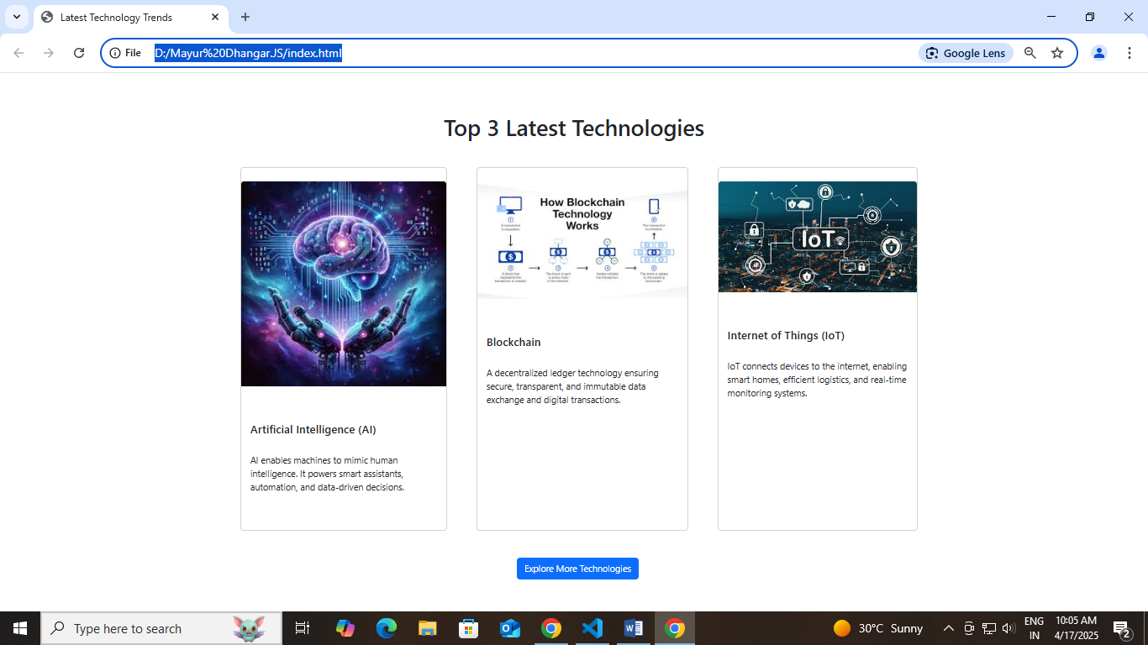

**Name:-Abhya Ulhas Kumawat Roll No:- 178 Batch:- B6**

**Div:- B**

**Title:-1** **Basic JavaScript Program: Write a simple JavaScript program to perform arithmetic operations.**

<!DOCTYPE html>

<html lang="en">

<head>

<title>Document</title>

</head>

<body>

<script>

let num1 = 10;

let num2 = 5;

let addition = num1 + num2;

console.log("Adition:" + addition);

let subtraction = num1 - num2;

console.log("Subtraction:" + subtraction);

let multiplication = num1 * num2;

console.log("Multiplication:" + multiplication);

let division = num1 / num2;

console.log("Division:" + division);

</script>

</body>

</html>

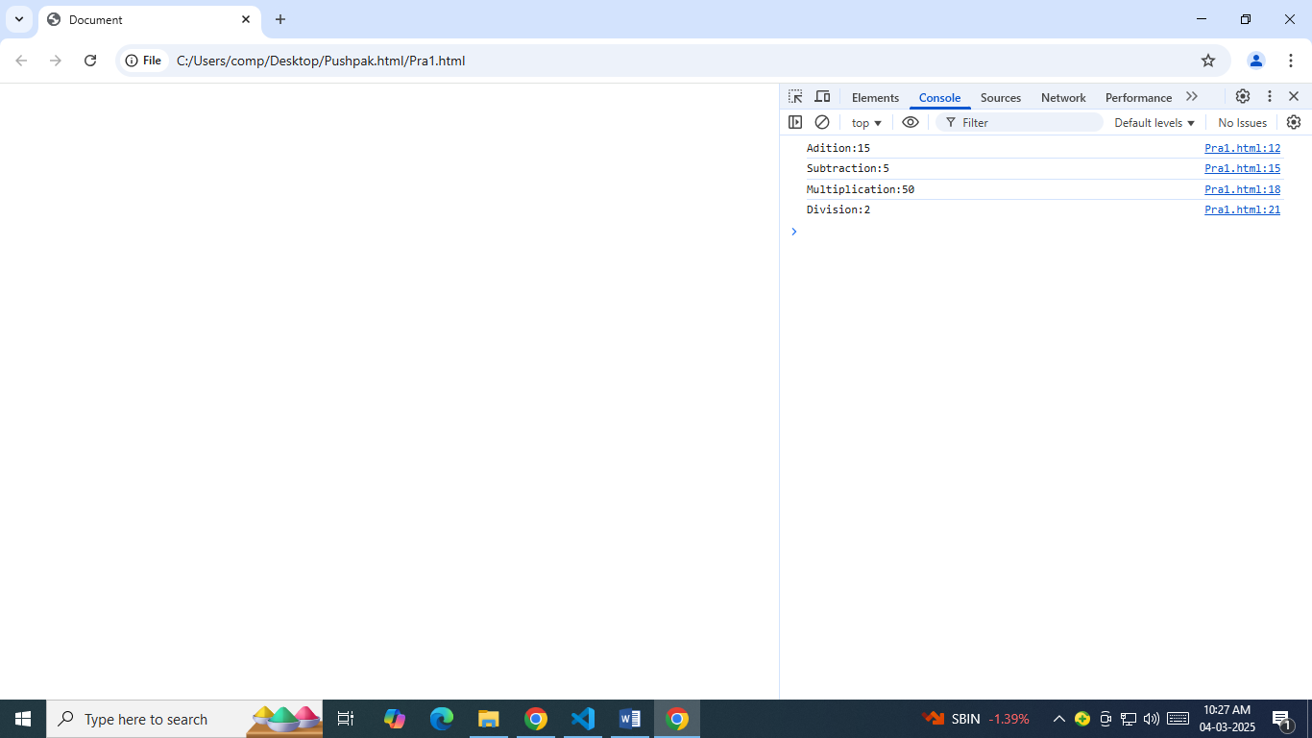

**Name:-Abhya Ulhas Kumawat Roll No:- 178 Batch:- B6**

**Div:- B**

**Title:-2** **Control Structures: Implement a JavaScript program using if-else statements and loops**

<!DOCTYPE html>

<html lang="en">

<head>

<title>Document</title>

</head>

<body>

<script>

let number = 5;

if (number > 0) {

console.log("The number is positive.");

} else if (number < 0) {

console.log("The number is negative.");

} else {

console.log("The number is zero.");

}

console.log("Numbers from 1 to " + number + ":");

for (let i = 1; i <= number; i++) {

console.log(i);

}

</script>

</body>

</html>

**Output:**

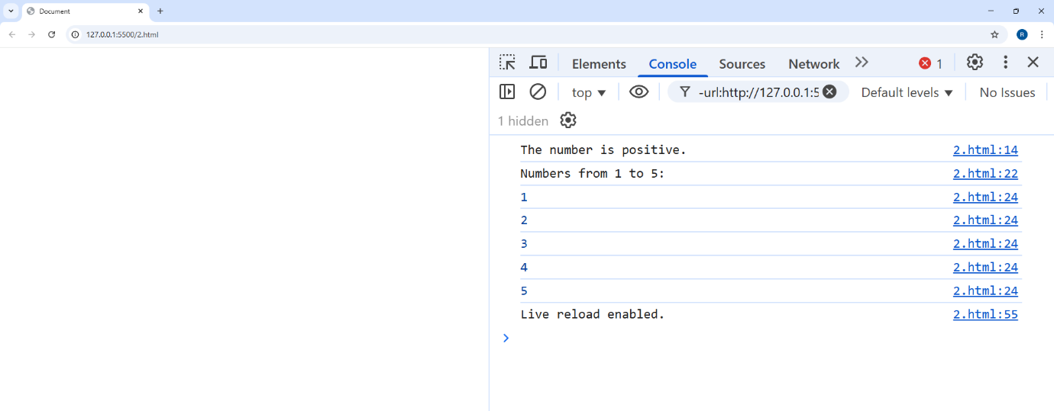

**Name:-Abhya Ulhas Kumawat Roll No:- 178 Batch:- B6**

**Div:- B**

**Title:- 3 JavaScript Functions: Create and invoke functions that perform specific tasks.**

<!DOCTYPE html>

<html lang="en">

<head>

    <title>Document</title>

</head>

<body>

    <script>

        function addNumbers(a, b) {

            return a + b;

        }

        function greetUser(name) {

            return "Hello, " + name + "!";

        }

        let sum = addNumbers(5, 2);

        console.log("Sum:", sum);

        let greeting = greetUser("Yash");

        console.log(greeting);

    </script>

</body>

</html>

**Output :**-

